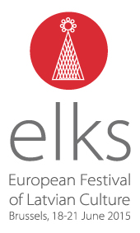 EUROPEAN LATVIAN SONG- AND DANCE CELEBRATION CONCERT
ELKS 2015

Introduction
A unique impressive traditional open-air show in the centre of Brussels, the heart of Europe. Celebrating Europe and the end of the first Latvian presidency of the EU through a surprising cultural exchange. Showing Brussels at its best to a national and international audience. This is what 1000 amateur singers and dancers will do during the European Latvian Song- and Dance Celebration Concert on June 20th, 2015. For sponsors a unique big public event with opportunities for great visibility.

The festival
The weekend before midsummer 2015, 1500 people with Latvian roots living around Europe will come to Brussels to celebrate the first Latvian Presidency to the EU. They will do this with a 4 days European Festival of Latvian Culture from June 18th-21st, organised by the European Latvian Association in co-operation with the Latvian association from 15 different countries.

The highlight of the festival will be a huge open-air concert on June 20th, the European Song- and Dance Celebration concert. Performed by 1000 Latvian amateur singers and dancers from around Europe, this concert goes back to a long Baltic yearly midsummer tradition, by Unesco renown as Masterpiece of Oral and Intangible Heritage to Humanity.

Because cultural exchange is a key element of the concert, some Belgian choirs have been invited to participate in the last and most festive part of the show.

They will do so by sharing with the Brussels and European community a piece of Latvian culture that has been recognized as a Masterpiece of Oral and Intangible Heritage to Humanity by the UNESCO. http://www.unesco.org/culture/ich/index.php?lg=en&pg=00011&RL=00087

Aim of the concert

The concert is all about connectedness, Brussels, Europe and cultural exchange. More specific it aims at:
1) Connectedness: We celebrate the first Latvian EU presidency as an important moment, without making any political statements. Therefore the concert is a celebration from and with people of all backgrounds and open to everyone, connecting citizens from many different countries through their passion for culture and music, traditions, the roost they share,…

2) Brussels: As an open-air event on a unique location in the centre of Brussels, we show Brussels at its best: a marvellous city and the lively heart of Europe, where people of different cultures meet, enjoy being there and exchange. This is not Brussels we know as the headquarter of the EU institutions, but a lively city of people.

3) Europe: people with common roots coming from 15 different countries in Europe share a unique part of their culture with each other and the other Europeans/the public of Brussels inhabitants, international communities, Belgians, choir singers, and tourists from around the world.
Historical background
The European Song and Dance Celebration Concert ELKS 2015 is part of a wider Baltic tradition of midsummer celebrations every year. At the centre of this tradition is the ALL Latvian Song and Dance Celebration that for more than a century takes place every five years, an impressive high standard performance with 30.000 singers and 15.000 dancers. Conductors and solo performers of these massive concerts deserve worldwide fame amongst choir lovers. For being so deeply anchored in the Baltic culture and because of their incredible high standard of quality, they UNESCO has recognized the Baltic Song- and Dance celebrations as a Masterpiece of the Oral and Intangible Heritage of Humanity.
http://www.unesco.org/culture/ich/index.php?lg=en&pg=00011&RL=00087

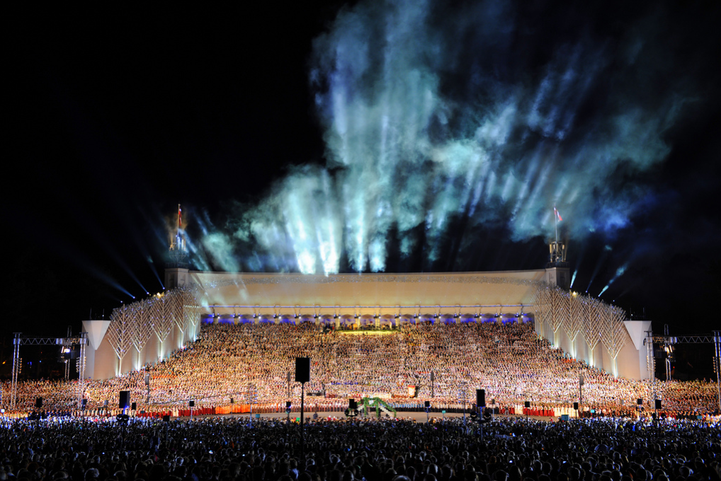
ALL Latvian Song and Dance Celebration, Riga 2013 - 30.000 singers and
15.000 dancers were bringing on stage an incredible high standard show.

Discover more about this midsummer tradition in this 4 minutes video:
https://www.youtube.com/watch?v=TYIgwyML7WQ

The last edition in 2013 could count on an audience of 50.000 people live and some 800.000 people watched the 6 hours show on TV.

As Latvians have large diaspora communities in Europe and other parts of the world, regional song and dance celebrations take place on a small scale in countries in Europe, America, Canada, and Australia. The Brussels celebration in June 2015 will be the first European edition again since 1989.

The programme

The European Regional Latvian Song and Dance Celebration concert on Saturday night 20th of June will be a 3 hour song and dance show, open to the broader public for free.

A stage for 1000 singers and dancers will be built on the magnificent Square Albertina, Mont des Arts/Kunstberg with room for 2000 spectators (seated and standing).

The general concept is that as many people as possible can walk by and watch as long as they wish – standing. That’s why we chose this location: it is in the centre of Brussels, it is unique with a marvellous view on the old city. Actually the old city will be the side scene for this concert!

250 seats will be reserved for special guests, partners, sponsors and donors. Tickets for seats are also for sale (in pre-sale only) for those who are keen to see the entire spectacle in a comfortable way.

Prior to the concert sponsors, partners and special guests will be welcomed during a VIP reception with drinks and finger food (combination of Belgian and Latvian specialities) with network opportunities between Belgian and Latvian companies.

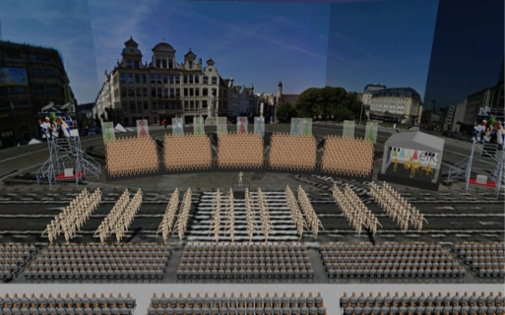
Mock-up of the stage
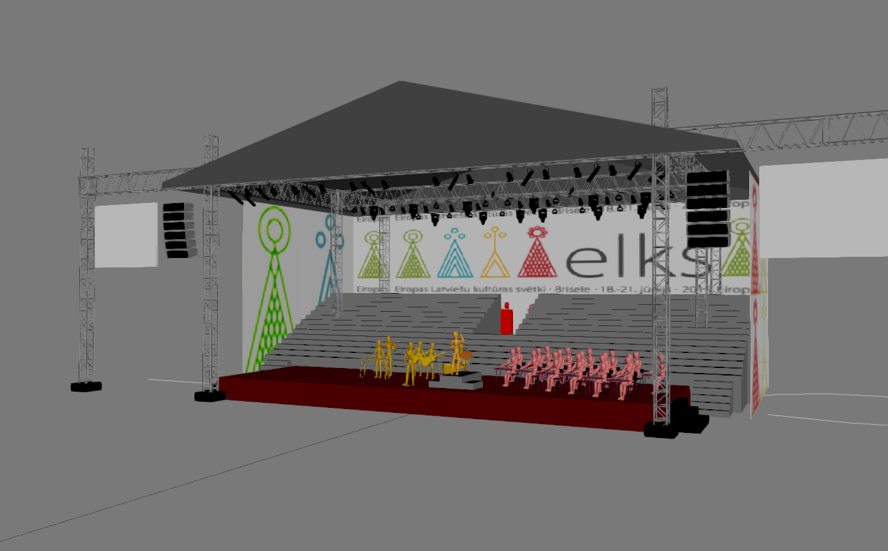

The baseline of ELKS is “Tradition in a new form” – meaning that we are bringing a traditional midsummer celebration to Brussels, but with some new elements. Internationally renowned artists like Renars Kaupers, lead singer of the famous Latvian band Brainstorm, will enrich the concert with a solo performance. Also some Brussels/Belgian choirs are invited to sing the last and most festive part of the concert together with the singers from ELKS2015.

Prior to the concert, the 1000 dancers and singers will walk in a parade through the city centre of Brussels towards the Mont des Arts – attracting a lot of attention to their show.

Communication

OWN COMMUNICATION EFFORTS
The full programme of the festival and the Dance and Song Celebration concert on Saturday night, together with pictures, background information is published on our special website www.elks2015.eu. Tickets can be bought here as well. All our communication tool will lead people to our website (in Latvian language, accessible in English as of end March 2015, partially also in French and Dutch)

A social media campaign starts as of March via Facebook, Twitter and Linked-In, connecting with people around Europe interested in Baltic/Latvian culture, choir lovers in Belgium and touristic organisations.

The day before the grand concert, flash mob events in 5 different places around the city of Brussels will attract the attention to the event of people passing by. Because of the focus on Europe and Brussels, a special small concert in front of the European institutions is also foreseen.

A poster and flyer campaign is also foreseen in Brussels commercials. During
flash mob events and during the parade prior to the concert we will distribute flyers as well.

MEDIA
For the announcement and media-coverage of the event afterwards, a special media campaign (on and off line) is foreseen in Latvia and Belgium, with specific focus on Brussels, looking for media partnerships at French and Dutch speaking side in Belgium. Because of the importance of this sing and dance tradition in Latvia, because of the first Latvia EU presidency and because of the fact that this is the first European song and dance celebration after 25 years, we expect huge media interest in Latvia. Also for Belgian media this is a unique event. Therefore in Belgium we are working towards some media partnerships with focus on Brussels media and some cultural oriented national media (mainly radio).

On multilingual activity-websites (Que faire? Wattedoen? Agenda.be etc.) we are announcing the concert as well. Agenda.be serves as database for many other cultural websites in Belgium (Culture.be, cultuurplatform.be,…) that are highly used by a specific cultural interested public.

PARTNER COMMUNICATION

Partners in the artistic area, the European community and the touristic sector in Brussels are asked to support our communication efforts via their own communication channels towards specific audiences. Several agreements are concluded yet with Visit Brussels (special newsletters, info on welcoming screens in all Brussels hotels,…), Culture.be, Uit, Davidsfonds,….

COMMUNICATION DURING THE CONCERT
During the festival two publications will be spread:
- A festival programme booklet for participants and spectators with all information about the 3 days festival programme, Brussels and the venues.
- A songbook for the participants

Since this is an outdoor event at a very special location in the centre of Brussels, we will use the location in our communication as much as possible. There will be opportunity for sponsors to have a maximum visibility on the concert location itself on the fences and on LED screens. Special LED screens will be set up next to the stage to show logos and/or video material of partners and sponsors.

Sponsoring/partnership

Next to public and own funding that has been acquired, we are looking for sponsors who are interested in this big public event. In return for your investment you can get visibility during the event and in our communications. Depending on your zone of interest we can focus on regional, national or European visibility. Any other specific focus can be discussed with potential sponsors.

Sponsoring or partnering the event will give you visibility in Brussels
- Amongst the broader Brussels public (people living in Brussels, tourists and a big expats)
- With a pan-European audience of participants and their friends and families having special links with Latvia. These are people who are used to travel between European cities (and Riga)
- With lovers of musical heritage who are open to discover new things

Sponsoring or partnering the event will also give you great visibility in Latvia via Latvian television. Since the song and dance celebration is so deeply anchored in Latvian society and because of the momentum of the Latvian presidency of EU, media attention in Latvia will be big.
Groups of sponsors

Small sponsors (up to 5000 €)
Different possibilities negotiable upon budgets and focus of sponsor:
- logo on ELKS website
- 1/4 page advertisement in festival guide
- logo on posters and flyers
- invitation to VIP reception
- 5 duo tickets

Middle sized sponsors (10 000 €) – limited to max. 4
- logo on website
- 1 page advertisement in festival guide
- logo on LED screen during concert
- publicity on fences around concert location
- logo on posters and flyers
- invitation to VIP reception
- 10 duo tickets

Main sponsors (as of 25.000 €) – limited to max. 2
- logo on website
- double page advertisement in festival guide
- logo or video on LED screen during concert
- publicity on fences around concert location
- logo on posters and flyers
- active announcement and links on ELKS website (high visibility) and social media
- announced as partner in all ELKS communications (press releases and reception)
- possibility to expand visibility during the concert -> to be negotiated: ex. Specific video material on LED screens next to the stage, flyering or own booth on concert site, publicity in festival kit for participants of the entire festival,…
- invitation to VIP reception
- 25 duo tickets
NOTE: The sponsors should provide logo, video material, advertisements etc.

Organisation

The European Festival of Latvian Culture and the European Song- and Dance Celebration Concert have been initiated by the European Latvian Association (ELA) in Riga and is organised by ELA together with the Latvian Associations of 15 European countries: Spain, France, United Kingdom, Ireland, Belgium, Luxembourg, Netherlands, Austria, Germany, Denmark, Norway, Sweden, Finland, Estonia.

Honorary presidents of ELKS2015 are Miss Vaira Viķe Freiberga, former State President of Latvia, and Mr Valdis Dombrovskis, Vice-President of the European Commission.

Director is Aldis Austers, Chairman of the European Latvian Association.

A dedicated team in both Riga and Brussels is working on the preparation of the event, supported by an international artistic team.

Partners: Visit Brussels is our main partner for the event organisation of the concert, such as Muntpunt for the organisation of the festival.

Contact

ELA has its headquarters in Riga and is supported by a local team in Brussels.
For any questions regarding sponsoring, partnership and communication please contact Katleen Vandriessche in Brussels, katleenvd@gmail.com, 0496 10 28 56.

Full contact details ELKS 2015 director in Riga (Latvia):

Biedrība “Eiropas Latviešu apvienība”
Aldis Austers – director ELKS2015 and chairman of ELA
+371 2638 1774
Aldis.austers@gmail.com or elks@ela.lv

Contact details Brussels team:

Antoine François - production officer Brussels
+32 (0) 488 22 55 70
antoinefrancois86@gmail.com
Katleen Vandriessche – communication officer Brussels
+32 (0)496 10 28 56
katleenvd@gmail.com

Attachmement 1: Full festival programme
18 June
8:00 | 16:00 | Participants arrival
16:00 | 20:00 | Participants registration
20:00 | 23:00 | Opening and guest artist concert - Getting to know evening
19 June
10:00 | 11:00 | Small Concert in front of the European Parliament
10.00 | 20:00 | Literary and artistic activities in Muntpunt library
12:00 | 14:00 | Flash mobs - Smaller concerts at various places in the city centre (Muntpunt, Ravenstein, Rue aux choux, Place Sainte-Catherine,
14:00 | 17:00 | Rehearsal for dancers
17:00 | 20:00 | Rehearsal for choirs
20:00 | 22:00 | Performance by the Brussels Latvian Theater “Vēlreiz Silmačos” in Woluwe St.Lambert Community Centre
21:00 | 0:00 | Guest artist concert
20 June
9:00 | 14:00 | General rehearsal.
10:00 | 16:00 | Literary and artistic activities in Muntpunt library
12:00 | 14:00 | Performance for children in Muntpunt library
14:00 | 16:00 | Free time for participants
16:30 | 18:00 | Festival participants procession from old city till Mont des Arts  VIP reception with possibility to see the parade
18:00 | 21:00 | Grand song and dance concert
21:00 | 2:00 | After party
21 June
13:00 | 15:00 | Church service (poss. Basilique de Koekelberg)
15.00 | 17:00 | Concert “Dievs, Tava zeme deg” in Cathédrale Saint-Michel et Gudule
12:00 | 18:00 | Excursions
18:00 | 23:00 | Thank you party
18:00 | 0:00 | Participants heading homewards

Lunches and diners are at own expenses of the participants – in Brussels horeca.

